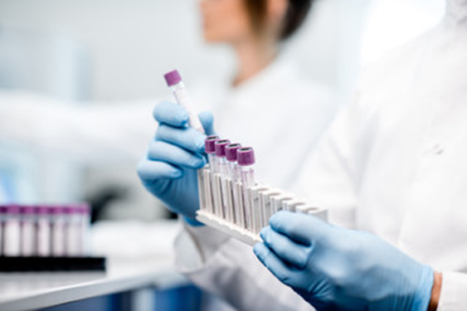  Il CRBA organizza dei seminari tematici  La partecipazione è libera  Contattaci  crba.laboratorio@unibo.it | Calendario Seminari CRBA 2018  prof. Giuseppe Gasparre  Direttore del CRBA | Seminari (sempre alle ore 14.30)  19/10 Francesca Fornari (Dimec - CRBA) : “To be a researcher at CRBA: scientific challenges and ‘lab sharing’’, Aula Placitelli Pad. 25 pt  26/10 Giulia Piazzi (Dimec - CRBA): “Chemoprevention of colorectal cancer by dietary compound”  9/11 Maurizio Baldassarre (Dimec - CRBA): “Structural and functional profile of human serum albumin: clinical implications in hospitalized patients with cirrhosis”  30/11 Marina Naldi (Fabit – Proteomica CRBA): “Mass spectrometry-based approaches for protein analysis” (auletta di ginecologia, Pad. 4 pt Policlinico S.Orsola)  7/12 Valeria Relli (Dimes - CRBA): “Molecular characterization of Trop-2 pathway in tumor growth” (aula Placitelli, Pad. 25 pt Policlinico S.Orsola)  14/12 Marianna Penzo (Dimes - Patologia) : “Ribosome heterogeneity and its role in human disease” (aula Placitelli, Pad. 25 pt Policlinico S.Orsola)

